**The Dawn of a New Era: How AI is Transforming the World**

[Artificial Intelligence (AI)](https://en.wikipedia.org/wiki/Artificial_intelligence) has emerged as one of the maximum transformative forces of the 21st century. From revolutionizing industries to reshaping day by day existence, AI is using extraordinary modifications across the globe. This technological surprise, often shrouded in both excitement and apprehension, is poised to redefine the very material of our world. But what precisely does this alteration entail, and how is AI influencing various sides of our lives?

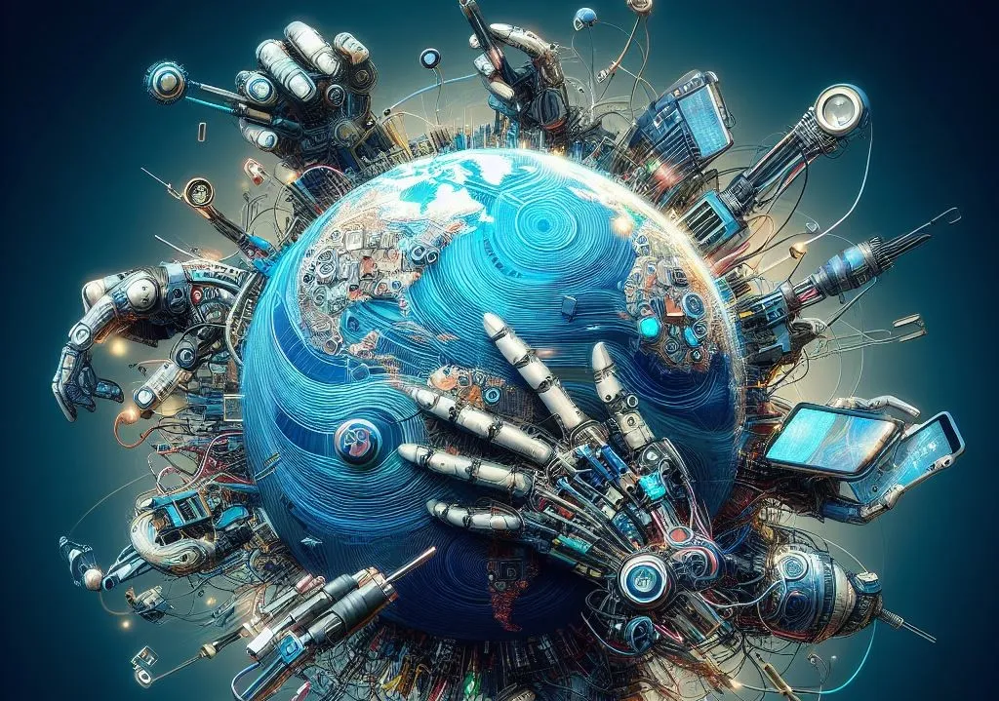

**Revolutionizing Industries**

One of the maximum seen impacts of AI is its profound impact on various industries. In healthcare, AI algorithms are permitting in advance and extra correct diagnoses. For instance, AI-driven imaging gear can stumble on anomalies in clinical scans with extraordinary precision, regularly identifying conditions like cancer or neurological issues at earlier stages than traditional methods. This early detection is important and crucial for enhancing patient effects and personalizing remedy plans.

In the area of finance, AI is remodeling and defines how we manage and invest money. Algorithms analyze enormous quantities of marketplace records to expect tendencies, optimize portfolios, and execute trades with pace and accuracy way ahead of past human abilities. This has no longer only democratized the right of entry to funding possibilities but also made financial markets extra efficient.

**Enhancing Daily Life**

AI is precise but has a major effect on our everyday life in addition to the nation-states’ expert. Virtual assistants like [Siri](https://machinelearning.apple.com/research/hey-siri), [Alexa](https://medium.com/geekculture/alexa-and-the-technology-behind-it-e5c00793f85), and Google Assistant have become such an integral part of our lives that they help us schedule tasks, control smart home devices, and even be our companions. Typically, these AI systems are learning from user interaction, which is why they are getting more accurate and functional as the years go by.AI’s influence is also clear in the field of entertainment. AI is used by streaming services like [Netflix](https://www.netflix.com/in/) and [Spotify](https://open.spotify.com/) to analyze data about the customer’s viewing and listening behavior, and thus, provide audio and video recommendations that will enhance the user’s experience. This tailoring is not only about convenience; it is about fostering a more engaging and varied conversation with digital content material.

**Transforming Education and Work**

Education is a few other places where AI is growing a large impact. Intelligent tutoring systems can adapt to the gaining knowledge of pace and fashion of character college college students, imparting personalized manual and comments. This adaptive gaining knowledge of the era facilitates addressing various instructional desires and gives a more tailor-made instructional experience.



In the workplace, AI is automating ordinary obligations, allowing employees to be interested in more complex and progressive components in their jobs. From automating information access to improving choice-making through predictive analytics, AI is boosting productivity and efficiency. However, this shift additionally raises questions on hobby displacement and the want for upskilling, as roles evolve in reaction to technological improvements.

**Addressing Challenges and Ethical Considerations**

While the benefits of AI are substantial, it’s essential to deal with the demanding situations and moral issues that accompany this generation. Privacy issues, records protection, and algorithmic bias are important issues that want careful manipulation. Ensuring that AI structures are obvious, sincere, and used responsibly is important for preserving public consideration and maximizing the fine impact of AI.

**The Road Ahead**

As we are gazing into the future, AI's unexampled potential to reshape our world is epic. Autonomous cars that will make our roads safer and AI models that predict the climate that might help to address environmental concerns are amongst the millions of possibilities that the world of AI is offering us. Nevertheless, overcoming this period of great change requires careful regulation, continuous innovation, and a commitment to ethical norms.

By the way I am, AI is not just a unique invention; it's a revolution that is changing manufacturing and making other practices better, which in turn is propelling us to the next level of development. How can we decide on the right AI transformations, if at the same time we are going through the enthusiasm of innovation? The trail of AI is only just beginning and the power of AI to convert our globe is infinite.